April 9, 1915
The Holy Quran Enjoins Exemplary Treatment of Divorced and Widowed Women
I bear witness that none deserves to be served besides Allah and I bear witness that Muhammad is the servant and messenger of Allah. —
After this, I seek the protection of Allah from the accursed devil.
In the name of Allah, the Beneficent, the Merciful.
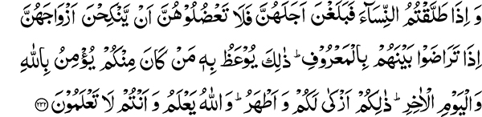
“And when you divorce women and they end their term, prevent them not from marrying their husbands if they agree among themselves in a lawful manner. With this is admonished he among you who believes in Allah and the Last Day. This is more profitable for you and purer. And Allah knows while you know not.” (2:232)
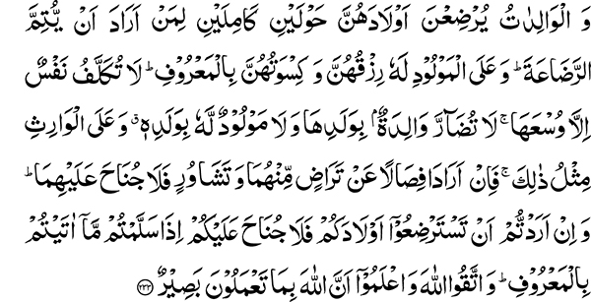
“And mothers shall suckle their children for two whole years, for him who desires to complete the time of suckling. And their maintenance and their clothing must be borne by the father according to usage. No soul shall be burdened beyond its capacity. Neither shall a mother be made to suffer harm on account of her child, nor a father on account of his child; and a similar duty (devolves) on the (father’s) heir. But if both desire weaning by mutual consent and counsel, there is no blame on them. And if you wish to engage a wet-nurse for your children, there is no blame on you so long as you pay what you promised according to usage. And keep your duty to Allah and know that Allah is Seer of what you do.” (2:233)
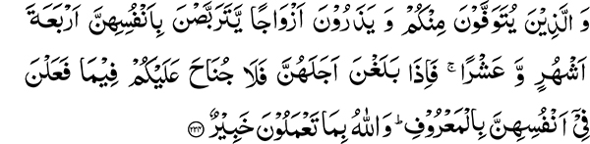
“And (as for) those of you who die and leave wives behind, such women should keep themselves in waiting for four months and ten days; when they reach their term, there is no blame on you for what they do for themselves in a lawful manner. And Allah is Aware of what you do.” (2:234)
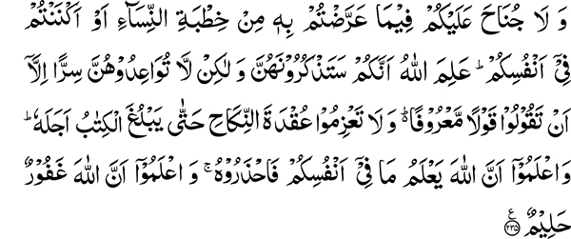
“And there is no blame on you respecting that which you speak indirectly in the asking of (such) women in marriage or keep (the proposal) concealed within your minds. Allah knows that you will have them in your minds, but give them not a promise in secret unless you speak in a lawful manner. And confirm not the marriage tie until the prescribed period reaches its end. And know that Allah knows what is in your minds, so beware of Him; and know that Allah is Forgiving, Forbearing.” (2:235)
The Path of Extremism in Relationships Between Men and Women
This is the third section of the Holy Quran. It discusses the subject of divorce. There is one more section after this one as well as further injunctions in another section. There is a small chapter of the Holy Quran dealing with the subject and to some extent it has been discussed in the chapter, “The Women.” Allah the Most High has given special importance to this subject because the marital relationship between man and woman is fundamental to the wellbeing of society. Basic lessons for social intercourse begin at this point. Social intercourse means the ability to live together with other human beings. The relationship between a husband and wife is the first step in this direction. In pre-Islamic Arabia, before the advent of the Holy Prophet, there was prevalence of extreme behaviors in the matter of divorce. There were those who took the position that the marriage contract was unbreakable while others were ready to divorce upon the slightest provocation.
The Well Being of Society is Dependent upon Good Relations Between Husband and Wife
All worldly relations have their foundation based upon the relationship between husband and wife. This is the reason why it has been given such importance. The Holy Prophet said: “The best of you is he who treats his wife well.” This relationship serves as an example for other relations. Those who cannot treat members of their household in a good manner are not capable of treating those outside the family circle equitably. Islam has thus laid down the basic principles from which many lessons can be learned. For example, it is enjoined not to serve anyone besides Allah. With this, however, obedience to parents is made mandatory, because parents are responsible for nurturing their children to a large extent. As I have mentioned, it is essential to serve any person to the extent they provide for us. This is why a man’s treatment of his wife has been set up as the standard for his dealings outside. Besides other moral deficiencies, a very prevalent one amongst Muslim men is being short-tempered in dealing with their spouses. Those who cannot control their temper at home have difficulty in their dealings outside.
Domestic relations thus serve as a standard for outside behavior. Many practical moral lessons are learned in one’s dealings with their wives. If you want to manifest goodness in character, then be a good example at home. In this way, you can also serve as a good example for your children. Islam has aimed at social uplifting by enjoining excellence in one’s domestic relationship. This is the key to the success or failure of a civil society.
It is stated: “And when you divorce women and they end their term, prevent them not from marrying their husbands if they agree among themselves in a lawful manner.”
Islam Considers Temporary Marriage (halalah) an Immoral, Abhorrent, and Accursed Custom
Amongst pre-Islamic Arabs, it was considered dishonorable to marry divorced women, while other religions have declared it altogether illegal. The Holy Quran rejected this old custom. A person reacting in anger may say something and afterward regret it and change his opinion. Under such circumstances, he should be given the benefit of doubt and if both parties are agreeable allowed to remarry. Some Muslims have come up with temporary marriage, which is an accursed and abhorrent custom. The Holy Quran does not enjoin any form of temporary marriage.
“…This is more profitable for you and purer. And Allah knows while you know not.” (2:232)
Divorce and the Infant Child
Another difficulty is encountered when a divorce is given and there is an infant child. What should be done with him? The Holy Quran tells us: “And mothers shall suckle their children for two whole years, for him who desires to complete the time of suckling.” This is for those who want to complete the period of suckling but the mother should be compensated for her services: “And their maintenance and their clothing must be borne by the father according to usage.” Usage is according to the means of the father. If he is a rich person, food and clothing should be in accordance with his level of income and if his means are limited he should provide support accordingly. This is to ensure that: “No soul shall be burdened beyond its capacity. Neither shall a mother be made to suffer harm on account of her child, nor a father on account of his child.” The mother should not be held back and mistreated on account of her child nor should the father be burdened beyond his means. ‘And a similar duty (devolves) on the (father’s) heir.” In other words, if the father of the child dies, then his heir has to fulfill the maintenance commitment.
“…But if both desire weaning by mutual consent and counsel, there is no blame on them.
“And if you wish to engage a wet-nurse for your children, there is no blame on you so long as you pay what you promised according to usage. And keep your duty to Allah and know that Allah is Seer of what you do.” (2:233)
Kind Treatment of Divorced Women
A waiting period is recommended after divorce and also in the case of women who become widowed. In the latter case, it is stated:
“And (as for) those of you who die and leave wives behind, such women should keep themselves in waiting for four months and ten days; when they reach their term, there is no blame on you for what they do for themselves in a lawful manner. And Allah is Aware of what you do.”
“And there is no blame on you respecting that which you speak indirectly in the asking of (such) women in marriage or keep (the proposal) concealed within your minds. Allah knows that you will have them in your minds, but give them not a promise in secret unless you speak in a lawful manner. And confirm not the marriage tie until the prescribed period reaches its end. And know that Allah knows what is in your minds, so beware of Him; and know that Allah is Forgiving, Forbearing.” (2:234-235)
The Purpose of the Waiting Period
Why is there a waiting period? The reason for this is that if the woman is pregnant, her pregnancy should become manifest. In the early stages of pregnancy, such a determination cannot be made readily and if the woman gets married at this stage, the paternity of the child would become doubtful. This is the reason why a waiting period of four months and ten days has been recommended. If the pregnancy becomes certain at this stage, then the waiting period can be extended until the child is born, otherwise she can marry another person.
A Few Rules for Resolving Differences Within the Ahmadiyya Movement
I have briefly mentioned to you the problems related to divorced and widowed women and solutions provided by the Holy Quran in these matters so that by firmly standing upon these principles you can benefit in your worldly matters. I am also drawing your attention to have an understanding and a firm grasp on certain basic principles. At this juncture, there is a matter of great dissension amongst members of the Ahmadiyya Movement. Seeing all this debate, people get so perplexed that they say, we do not know who is truthful. I will tell you the principle by which you can gauge the truth. If you say that the length of arguments is the standard by which to judge the truth, you should look at the philosophy of trinity. You will observe that large volumes of books have been written on this matter and many brilliant minds have wasted their time and monetary resources in this quest. Differences will always remain, as the Holy Quran tells us:
“And if thy Lord had pleased, he would have made people a single nation. And they cease not to differ.” (11:118)
It usually happens that true beliefs are endangered and errant beliefs initially attain great popularity. Remember a belief cannot be accepted as correct just because the majority of people are accepting it. If this is a valid argument, then presently those who believe in trinity are in the majority and many are still accepting this philosophy. Every time a census is carried out in India, we find their numbers to have increased substantially. Superiority in numbers therefore does not count for anything. In order to decide between truth and falsehood, the main principle should be understood and accepted. The rest of the differences will be decided spontaneously. I am saying this also because at this time Islam needs your services. If you spend all your energies in internal strife, your defenses will become weaker against outside attacks. It is essential that you first stand firm on a principle. Do not consume your energies in extremely complicated matters for you will not have any strength left to stand up to other religions.
The greatest internal difference we have is non-Ahmadi should be regarded as Muslim or non-Muslim. This also settles the matter of prophethood of the Promised Messiah. I will relate to you an incident that is easy to understand and will help you to decide regarding this matter. Somebody sought Hazrat Mirza Ghulam Ahmad’s opinion as to whether it was appropriate to say the funeral prayer for a person who is not a member of the Ahmadiyya Movement. If he had given the reply that since he was a prophet and one who does not accept a prophet becomes a disbeliever, and those who do not believe in him are disbelievers and it is not permissible to participate in their funeral, we would not have had any objection to accept this. His reply, however, has been documented in the publication, “Edicts of Ahmadiyya” (Fatawa-e-Ahmadiyya vol.i. p.118. statement made on April 18, 1902 and printed in Al-hakm newspaper April 30, 1902).
In this Hazrat Mirza Ghulam Ahmad clearly states: “If the deceased did not call us kafir (disbeliever) and a liar, his funeral prayers may be said. There is nothing wrong with that, for only God knows hidden matters.” It is a great inequity to put such a clear statement in the realm of allegorical. What may I ask then is a decisive statement?
A Disclosure that was not Even Made to the Promised Messiah
Mir Hamid Shah Sahib has written a lengthy discourse in which he makes this statement: “What has been disclosed in the book Truth about Prophethood and at which point the prophethood of Hazrat Mirza Sahib, who has returned to Allah, has been proven, if someone’s heart still does not accept it, it is shameful.” Unfortunately, this disclosure was not made to the Promised Messiah during his lifetime and neither to Mir Hamid Shah Sahib to this point in time. Moreover, he boldly asserts, “father misses, son completes,” in other words: ‘what the Promised Messiah (Hazrat Mirza Ghulam Ahmad) could not do, was accomplished by the son (Mian Mahmud Ahmad)’. And what is that accomplishment? It is the complete contradiction of the fatwa given by Hazrat Mirza Ghulam Ahmad.
Hazrat Mirza Ghulam Ahmad states clearly that it is permissible to say the funeral prayer for the deceased who is not a member of the Ahmadiyya Movement, “If the deceased did not call us kafir (disbeliever) and a liar.” According to Mian Mahmud Ahmad Sahib however, it is not permissible to say the funeral prayer for anybody who is not an Ahmadi. The following conversation attributed to him is worth noting.
A certain individual asked him, what do you command in the case where the wife of an Ahmadi passes away, and the concern is that non-Ahmadis won’t say her funeral prayer. All members of the household are Ahmadis but the deceased wife has not taken the pledge. He replied, “The one whose faith has not reached completion what can be the command for her funeral prayer?” (Al-Fazl April 24, 1915)
The Dangerous Precept of Calling Those who do not Follow the Ahmadiyya Movement, Disbelievers
Thus, according to Mian Mahmud Ahmad Sahib, the faith of this lady has not yet reached completion; therefore funeral prayer for her is not permissible. This is his verdict about the funeral prayer. It has not yet been decided if her burial rites should be performed in the Islamic tradition. In view of this opinion, there is no need for performing the funeral rites in the Islamic tradition and facing the grave in the direction of the Ka’bah. Why not just dig a hole and bury her? Another question also comes up in this context. There is a generally accepted Hadith, “a believer cannot be the inheritor of a disbeliever, nor a disbeliever of a believer.” Therefore, if a father is an Ahmadi and the son a non-Ahmadi the latter cannot inherit from the former. Similarly, a son who is an Ahmadi cannot inherit from a father who is a non-Ahmadi. Those Ahmadi children who have inherited from their non-Ahmadi parents have taken that inheritance against Sharia law. Those who have taken these prohibited funds should return them and abstain from spending their illegal gains for the benefit of their children. They are disobeying the principles of Sharia by consuming the property of disbelievers. Is it not the duty of those who issue such edicts that they should make arrangements for returning all the property of non-Ahmadis that has been inherited by their Ahmadi children? Is it not an essential component of faith to consume only what is lawful and good?
This is indeed a very dangerous precept. It is said that without following these precepts, relationships within the community are affected. I do understand that close ties of kinship are essential for national progress. If, however, your ties of relationship are strengthened by calling others disbelievers, then the very basis of this is laid upon commission of a great wrong. Remember the words of the Holy Quran: “And help one another in righteousness and piety, and help not one another in sin and aggression” (5:2). Lay the foundation of your kinship on the basis of truth, for a foundation laid on falsehood cannot sustain itself for long.
Do Not Term What is Decisive as Allegorical
I have given you a brief explanation. If anyone has any proof to the contrary, they should present it. If you relegate the clear statements and edicts of Hazrat Mirza Ghulam Ahmad to the realm of allegory and what has no proof behind it you term as a decisive opinion, then no tranquility and peace will remain. A Christian can very well say that all the arguments you present fall in the category of allegorical statements and the decisive position is three is one and one is three. This is of course an invalid argument; so for God’s sake abstain from such baseless issues. A person should not commit the same mistakes over and over again. Do the idolaters not present numerous arguments in a philosophical manner in support of idol worship? They will say that they do not worship idols; in fact they worship the One Supreme God and the idols are merely visible symbols to enhance this concept. Their argument is not valid because it goes against the established principle of the person and attributes of God. Do not abandon principle in this matter also. You cannot come to a decision by relegating your claim to the realm of allegory. By doing so, you are abandoning the very principle that is the foundation for all the rest. I am also telling you that by following an individual who is clearly going down the wrong path, you are intentionally doing something that goes against your intelligence and belief. A form of idol worship and association with Allah occurs when one starts following someone due to fear of malediction by that individual. Fear of such imprecations is cowardice and a form of association with Allah. You should abandon such thoughts, use your mind and intellect, take a stand on principles, and not falter in this matter.

Book written by Mian Mahmud Ahmad

